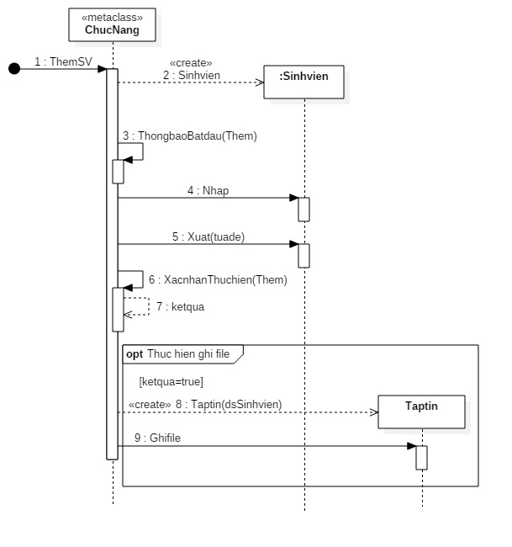

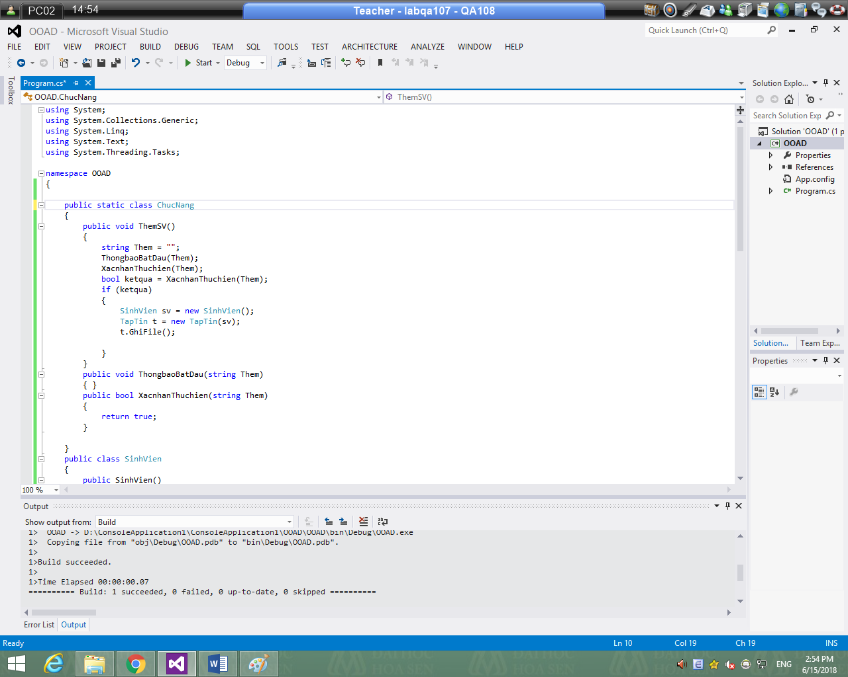

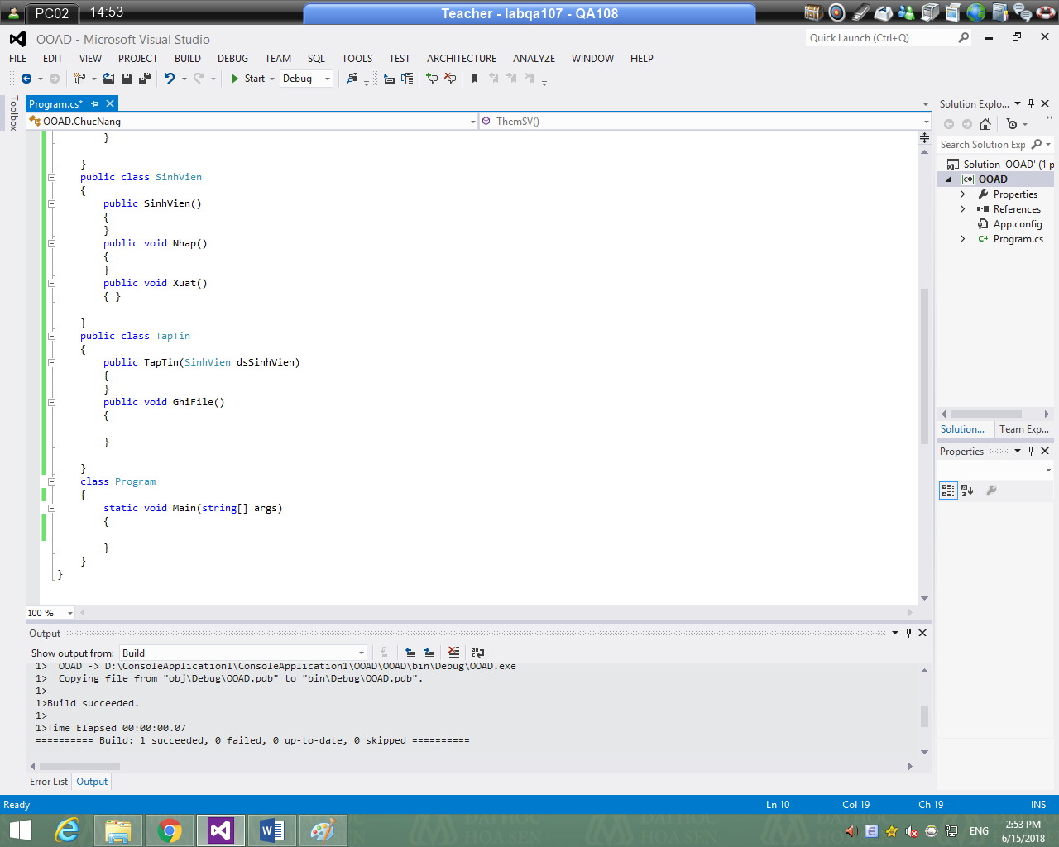

public static class ChucNang

{

public static void ThemSV()

{

string Them = "";

ThongbaoBatDau(Them);

XacnhanThuchien(Them);

bool ketqua = XacnhanThuchien(Them);

if (ketqua)

{

SinhVien sv = new SinhVien();

TapTin t = new TapTin(sv);

t.GhiFile();

}

}

public static void ThongbaoBatDau(string Them)

{ }

public static bool XacnhanThuchien(string Them)

{

return true;

}

}

public class SinhVien

{

public SinhVien()

{

}

public void Nhap()

{

}

public void Xuat()

{ }

}

public class TapTin

{

public TapTin(SinhVien dsSinhVien)

{

}

public void GhiFile()

{

}

}